**RAMCO INSTITUTE OF TECHNOLOGY, RAJAPALAYAM – 626 117**

**Department of Electronics and Communication Engineering**

**IOT ASSIGNMENT**

**TOPIC:**  Build a smart home in tinkercad use atleast 2 Sensors, Led, Buzzer in a circuit. Simulate in a single code

**NAME:** Abirami.V

**CODE:**

int trig = 2;

int echo = 4;

void setup()

{

pinMode(trig, OUTPUT);

pinMode(echo, INPUT);

Serial.begin(9600);

pinMode(7,INPUT);

pinMode(13,OUTPUT);

}

void loop()

{

//ultrasonic sensor

digitalWrite(trig,LOW);

digitalWrite(echo,HIGH);

delayMicroseconds(10);

digitalWrite(trig,LOW);

float dur = pulseIn(echo,HIGH);

float dist = (dur*0.0343)/2;

Serial.print("distance:");

Serial.println(dist);

//led

if(dist>=100)

{

digitalWrite(9,HIGH);

}

else

{

digitalWrite(9,LOW);

}

//motion sensor

int m=digitalRead(7);

Serial.print("motion detected:");

Serial.println(m);

if(m==1)

{

Serial.println("yes");

}

else

{

Serial.println("no");

}

//buzzer

if(m==1)

{

digitalWrite(13,HIGH);

}

else

{

digitalWrite(13,LOW);

}

//temperature sensor

double a=analogRead(A0);

double t=(((a/1024)*5)-0.5)*100;

Serial.print("Temp Value:");

Serial.println(t);

delay(1000);

//led

if(t>=100)

{

digitalWrite(8,HIGH);

}

else

{

digitalWrite(8,LOW);

}

}

**SIMULATION :**

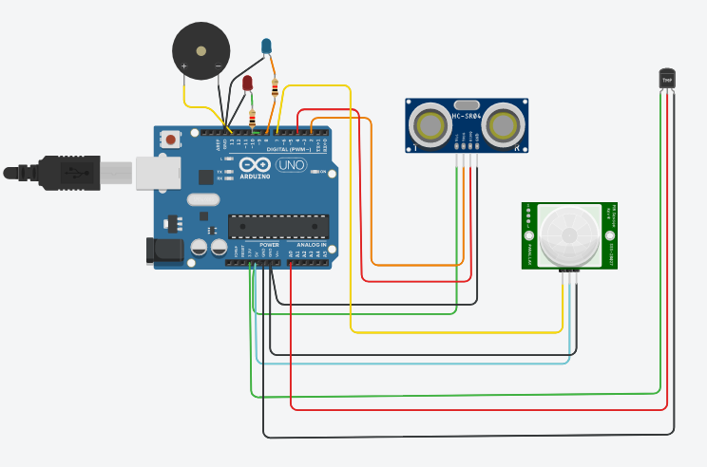

OUTPUT:

